Author: Allen F. Roberts

Samb, Mamadou Pape (1951-2014)

Mamadou Pape Samb, better known as Papisto Boy, was a Senegalese street artist celebrated locally and internationally. He moved to Dakar as an orphan of ten and would spend the next forty years living in an informal fishing village squeezed between factories in Dakar’s portside industrial park of Bel-Air. Papisto’s greatest artistic accomplishment was a two-hundred-meter-long mural covering the exterior walls of a fish-processing plant. His portraits and narrative vignettes celebrated global heroes of human rights, and Papisto greatly enjoyed recounting compelling stories about those depicted to local children or passers-by. The remarkable qualities of Papisto’s work were recognized in the late 1970s and he was brought to West Germany to exhibit his paintings in 1980. Later he participated in Dakar’s Set/Setal youth-empowering artistic revolution of the late 1980s. His works figured prominently in the exhibition ‘A Saint in the City: Sufi Arts of Urban Senegal’ that traveled to six U.S. museums from 2003 through 2008, and in ‘Urban Islam’ seen in Amsterdam (2004) and Basel (2006). Papisto’s last major work was a 2006 mural commissioned for the outer wall of the French Cultural Center of Dakar.

Papisto’s life was never easy, and after his community in Bel-Air was razed by city officials in 2002, his existence grew increasingly precarious until illness without formal healthcare led to his demise. Until his last days, though, Papisto remained an exuberant public intellectual, and despite his few years of formal education—as he explained, he was expelled from primary school because all he wanted to do was draw—he brought astonishing erudition to his painting. Through conversations with Senegalese university friends and the literature they lent him, Papisto depicted individuals whose histories he hoped would inspire the inhabitants of his Bel-Air community. No subject was more dear to him than Sheikh Amadou Bamba (1853-1927), the Sufi saint central to the Mouride Way that Papisto followed so fervently. He painted many portraits of Bamba surrounded by other notable persons from Gandhi to Bob Marley, Gerhard Hansen (the 19th-century Norwegian physician who identified the cause of leprosy) to Martin Luther King. All were Bamba’s emissaries to Papisto’s reckoning, for in their own ways they exemplified and furthered the saint’s teachings of religious tolerance, dedication to family, hard work, intellectual quest, and inner peace. The artist ‘Senegalized’ these world figures on his own terms, hoping that his paintings would bring the urban poor so readily invisible to so many, ‘faith to keep living and working’, as he explained. Papisto was a mild, generous, and witty man wise beyond words, and his Modernism—however discrepant—remains an expressive legacy for all the world’s downtrodden.

References and Further Reading

Diouf, M. (1992) ‘Fresques murales et écriture de l’histoire: Le Set/Setal à Dakar’, Politique africaine 46: 41-54.

Fichte, H., and L. Mau (1980) Die Wanderbilder des Papisto Boy, Frankfurt: Qumram.

http://www.fowler.ucla.edu/passport/papisto.htm.

Roberts, A. F., and M. N. Roberts (2003) ‘“Walls that Speak”: Public Art and Postcolonial Memory, in A Saint in the City: Sufi Arts of Urban Senegal, Los Angeles: UCLA Fowler Museum, 122-149.

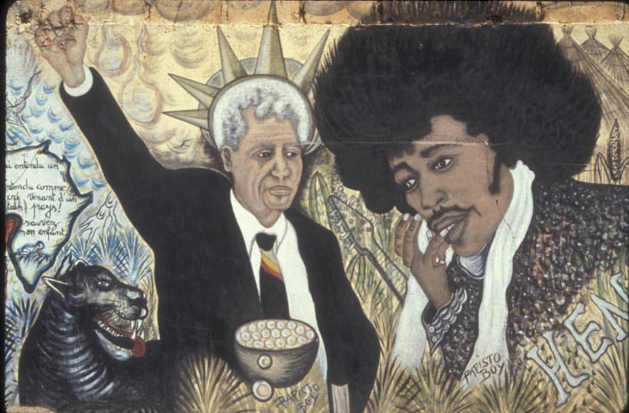

Narrative panel from the Bel-Air (Dakar, Senegal) mural of Mamadou Pape Samb (Papisto Boy). As the artist explained, a black panther protects Nelson Mandela who wears the crown of New York’s Statue of Liberty, while Jimmy Hendrix contemplates Mandela’s courage as well as the mystical powers of his own guitar music that he played as an emissary of Sheikh Amadou Bamba. A bleeding map of Africa bears the message ‘I heard a cry, heard like a cry from a far-off country! Save my child.’

Vignette of streetside mural, house paint on cracked concrete wall, approx. 300x210cm.

Photograph 1998, Dakar Senegal, M. N. Roberts and A. F. Roberts with permission.

